1. A basic Whiteboard that will ask you to select a pointer and then you write in air and it will show it on the whiteboard to the students.
2. Will be used in screenshare mode with videocalls.
3. Deploy a website for this
4. A feature: To switch colours for the marker
5. Basic Implementation module: Open CV(Search for better and advanced options).

FURTHER IMPLEMENTATION

BEST USAGES:

1. Colleges, Schools
2. Offices where blackboards are not available

**ABHIGYA**

LINKEDIN:

https://www.linkedin.com/in/abhigya02/

GITHUB:

abhi27-web

MEDIUM:

<https://medium.com/@abhigya006btit19>

**GAURISHA**

GITHUB: Gaurisha21  
  
**ARYAN**

GITHUB:aryangulati

**OUTPUTS:**

Permanent Bar graph

A bar graph representing positive, negative and neutral tweets in a day. Eg.:

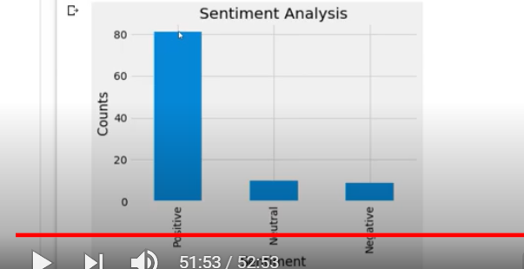

Searching Tabs

1. Location specific search for women abusing tweets
2. Time specific
3. Top users_ids of the day that tweet hate speech

Broad View

1. Monthly analysis of top ids that use hate speech
2. Yearly analysis(SAA)

**WORK DISTRIBUTION FOR 6 and 7 Decemeber:**

* Check that github account
* https://github.com/tanyagarg2509/Virago_MLProject

1. **Aryan**

* Check that github account section for WEBSITE deployment
* Start working on the basic structure of the website including design, graphics etc.

1. **Gaurisha & Abhigya -**

* **Data cleaning**
* **Building ML models**

GITHUB REPOSITORY:

<https://github.com/aryangulati/CODE_OFF_DUTY>

DATASET:

<https://www.kaggle.com/arkhoshghalb/twitter-sentiment-analysis-hatred-speech>

**WEBSITE TABS**

**TABS TO BE ADDED:**

1. **ABOUT WOMEN SAFETY(can also be called home page or landing page)**
   1. Textual info and some photos will be added

1. **STATISTICS**
   1. Basic stats about trolling and women bullying on twitter(can be picked up from websites like wikipedia etc.)

1. **TWITTER TODAY**
   1. Wordcloud and graphs for latest tweets will be represented here and some info about it.
   2. Live changing variables:

% of positive, negative and neutral tweets on women throughout the day.

1. TOP HATE_SPEECH USERS
2. Will have an option to filter location, will then show top users that have tweeted most hate speech in last 1 day in that location
3. All the things will be updated whenever a user opens the website

1. **MONTHLY & YEARLY ANALYSIS(Optional)**
   1. Will add in the end of the month.

1. **CREATORS**
   1. Info about 3 of us
   2. Name, email id and github, linkedin

**WEBSITE DESIGN**

**Wallpaper:**



**Name: Shabd/Aaveksh/**

**Slogan:** Woh Bachengi, Desh Bachega

**TAB 1: HOME**Facts to be added:

* "This amounted to one million (10 lakh) problematic or abusive mentions of the 95 women...or over 10,000 problematic or abusive tweets every day across all women in the sample," the report by Amnesty International India, a private human rights watchdog, has said.
* For the report, a sample of 1,14,716 tweets out of 70 lakh posts mentioning the women politicians during March-May 2019, in the run-up to and shortly after the 2019 Lok Sabha elections, were analysed and extrapolated for the results.